NURTURE COMMUNITY

DESIGN DOCUMENT

Contents

|  |  |
| --- | --- |
| Design  Deployment plan  System Design  DataBase Design | Page  2 |
| Api References  Signup  Sign in  Post available food  Update food list  Delete food lit  List of food items  View restaurant profile  Localized Search  Contact us | Page  2 - 8 |

# Application Design

* Deployment Design

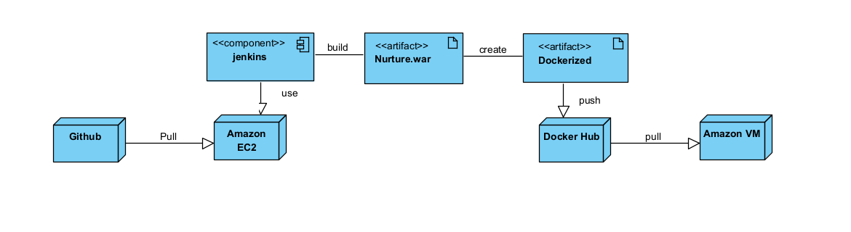

* System Design

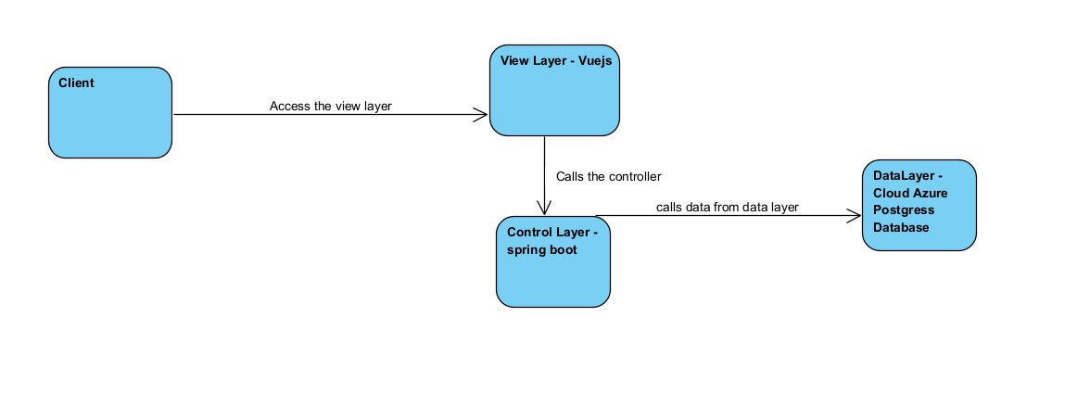

* Database Design

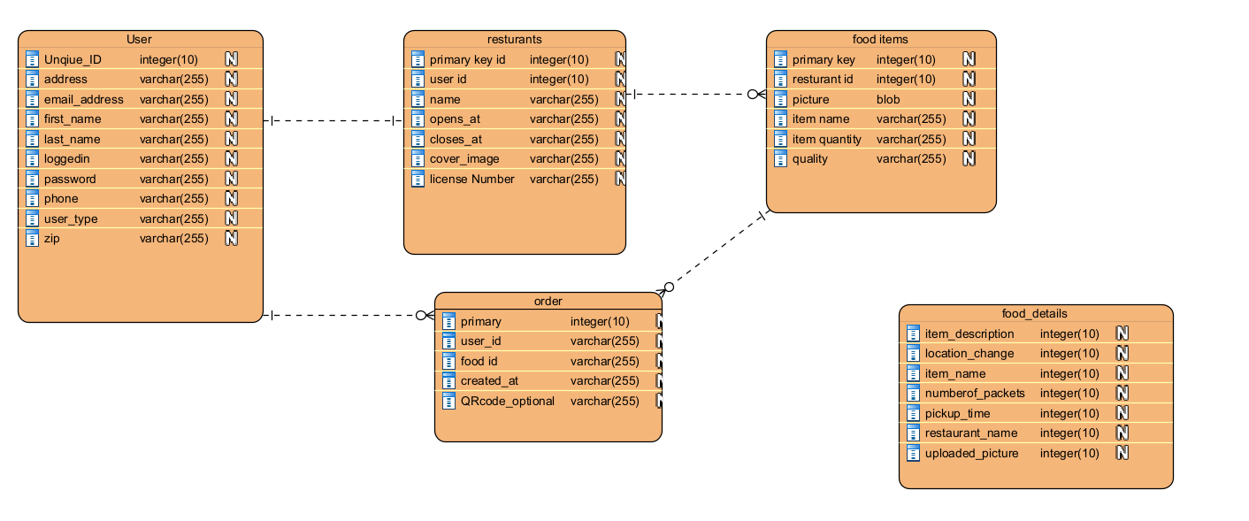

API Reference

Authentication

We used spring boot session token to authenticate the users and provide access to the api

Errors

We used conventional HTTP response codes to indicate the success or failure of an API request. In general: Codes in the 2xx range indicate success. Codes in the 4xx range indicate an error that failed given the information provided (e.g., a required parameter was omitted, etc.). Codes in the 5xx range indicate an error with our servers (these are rare).

1. **Sign up**

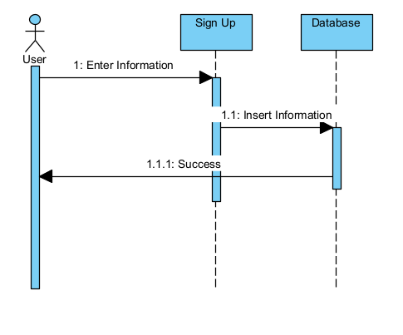

* Attributes
  + first_name: String
  + last_name : String
  + emailaddress: String
  + password : String
  + restaurant_name: String
  + license_number: String
  + address1: String
  + address2: String
  + city: String
  + province : String
  + country: String
  + phone: String
  + zip: String
  + usertype: String
  + opens_at: String
  + closes_at: String
  + loggedin: boolean
* Endpoint:
  + Api- path {/users/register }
* Response
  + HTTP status code 409 if the email address already exists
  + HTTP status code 200 for successful registration

1. **Sign in**

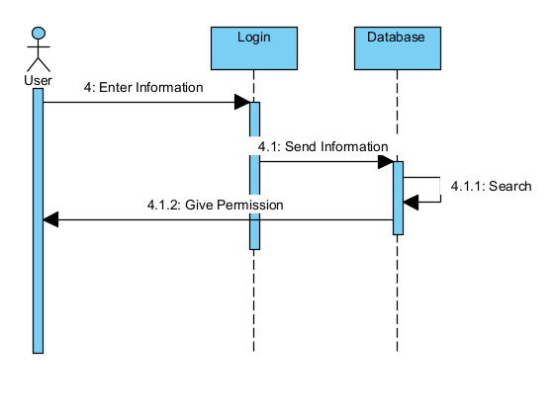

* Attributes
  + emailaddress : String
  + password: String
* Endpoint:
  + Api- path {/users/login }
* Response
  + Http Status code 401 for Unauthorized
  + Http Status code 200 for successful login

1. **Post Available food**

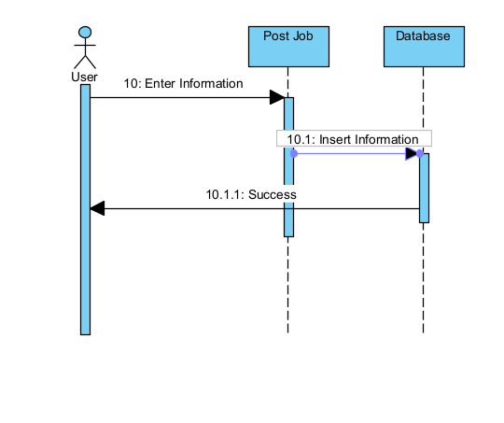

* Attributes
  + Id : int
  + RestaurantName String
  + Address1: string
  + Address2: string
  + City: string
  + Country: string
  + Item_description: string
  + Item_name : string
  + Number_of_packets: int
  + Pickup_time : string
  + Picture : mulitpart
  + LocationChange: String
  + Province :String
* Endpoint:
  + Api- path {/addFoodDetails }
* Response
  + HTTP status code 200 for successful completion

1. **Update Food List**

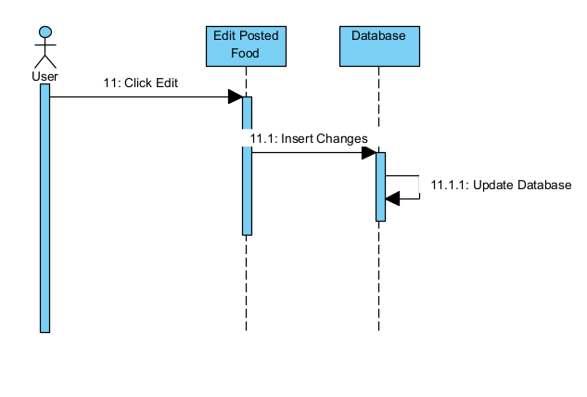

* Attributes
  + FoodId : int
  + Numberofpackets: int
* Endpoint:
  + Api- path {/updateFood{foodid: int}}
* Response
  + HTTP status code 200 for successful completion

1. **Delete Posted Food**

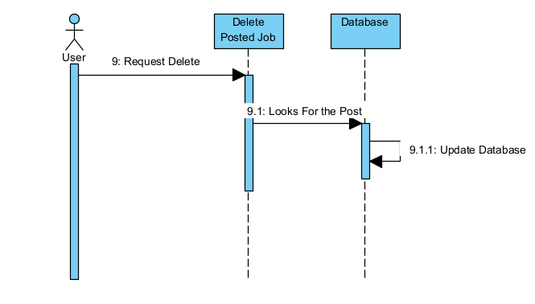

* Attributes
  + FoodId :int
* Endpoint:
  + Api- path {/deleteFood{foodid : int}}
* Response
  + HTTP status code 200 for successful completion

1. **List of Food in a Restaurant**

* Attributes
  + List of Food: array of foods
    - Give a List of food items that is posted by the restaurants
* Endpoint :
  + {/Listoffooditems{foodid : int}}
* Response:
  + get Food List Post Request Send -
  + Food_id : int
  + Address: string
  + City: string
  + Country: string
  + Item_description: string
  + Item_name : string
  + Number_of_packets: int
  + Pickup_time : string
  + Uploaded_picture : mulitpart

1. **List of Restaurant**

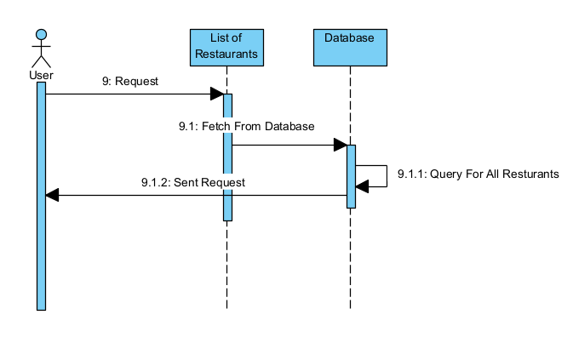

* Attributes
  + Get request which retrieve all the restrarutants
* Endpoint
  + {/ListOfRestaurants}
* Response:
  + Food_id : int
  + Address: string
  + City: string
  + Country: string
  + Item_description: string
  + Item_name : string
  + Number_of_packets: int
  + Pickup_time : string
  + Uploaded_picture : mulitpart

1. **View Restaurant Profile**

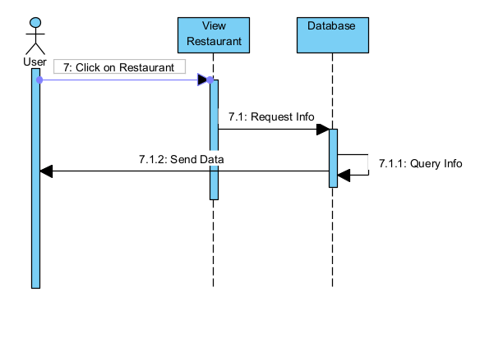

* Attributes
  + Id of restaurant is sent as path variable of Post request
* Endpoint
  + {/profile/{id} }
* Response:
  + Food_id : int
  + Address: string
  + City: string
  + Country: string
  + Item_description: string
  + Item_name : string
  + Number_of_packets: int
  + Pickup_time : string
  + Uploaded_picture : mulitpart

1. **Localized Search**

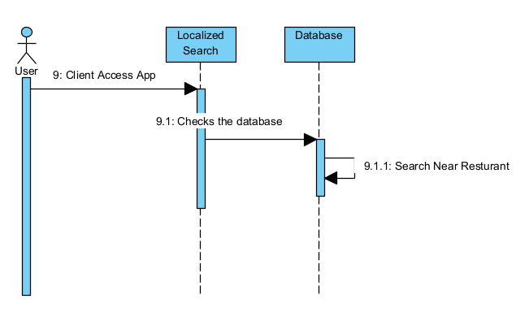

* Attributes
  + City: String
  + Zipcode: String
* Endpoint
  + {/ListOfRestaurantszip}
* Response:
  + Food_id : int
  + Address: string
  + City: string
  + Country: string
  + Item_description: string
  + Item_name : string
  + Number_of_packets: int
  + Pickup_time : string
  + Uploaded_picture : mulitpart

1. **Contact Us**

* Attributes
  + Name: String
  + Email: String
  + Phone: String
  + Message: String
* Endpoint
  + {/ ContactUs }
* Response:
  + HTTP status code 200 for successful completion